Dynamic Hardware Testing Breakdown

# Overview:

An ESP32 microcontroller is being used to interact with the dynamic hardware implementations on the Pynq-Z2. Some of the pins of the ESP32 will be used for input/output interactions while some onboard pins/LEDs of the Pynq-Z2 will be used. Each implementation will be notated with a corresponding “Pin Layout diagram.”

# Hardware Documents:

## Official documentation for Signal -> PL Pin for Pynq Z2

<https://d2m32eurp10079.cloudfront.net/Download/pynqz2_user_manual_v1_0.pdf>

## HiLetgo NodeMCU-32S Pinout

## Picture of testing setup

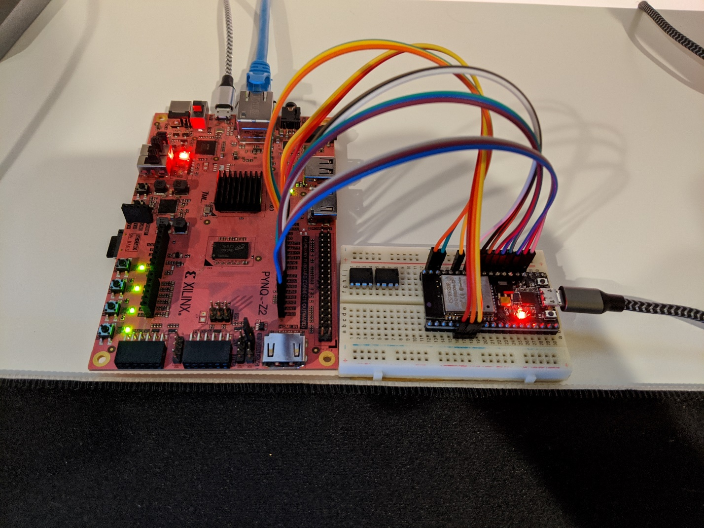

# DH Implementation: “reconfigMultiply.v”

|  |  |  |  |
| --- | --- | --- | --- |
| Pin Layout | | | |
| Data Signal Name | ESP32 Pin Name  (if connected) | Pynq Z2 Pin Name | Package Pin | |
| dataIn(3) | GPIO0 | AR0 | T14 | |
| dataIn(2) | GPIO2 | AR1 | U12 | |
| dataIn(1) | GPIO15 | AR2 | U13 | |
| dataIn(0) | GPIO17 | AR3 | V13 | |
| dataOut(3) | N/A | LD3 | M14 | |
| dataOut(2) | N/A | LD2 | N16 | |
| dataOut(1) | N/A | LD1 | P14 | |
| dataOut(0) | N/A | LD0 | R14 | |
| bufferEN | GPIO16 | AR4 | V15 | |
| bufferRD | GPIO4 | AR5 | T15 | |
| bufferSelect | GPIO19 | AR6 | R16 | |
| chunkCount | N/A | SW0 | M20 | |
| Clk | GPIO18 | AR7 | U17 | |
| FULL0 | GPIO5 | AR8 | V17 | |
| FULL1 | GPIO23 | AR9 | V18 | |
| mReady | GPIO21 | AR11 | T16 | |
| mStart | GPIO22 | AR10 | R17 | |
| Rst | GPIO32 | AR12 | D19 | |